Solar House Report

Milestone #4

Jason Younan

**TABLE OF CONTENTS**

**Page**

Executive Summary………………………………………………………………………… 2

Our Design……………………………………………………………………………………… 3-5

Schedule Report……………………………………………………………………………… 6

MATLAB Model………………………………………………………………………………. 7-9

Drawings and Graphs……………………………………………………………………… 10

Justifications of Decisions……………………………………………………………….. 11

**Executive Summary**

The designer was given a task to turn the client’s home into a solar home where they will be able to go off the grid during the winter months. After much research, calculations, and modeling the team made it possible. With a total of 19 monocrystalline solar panels and 4 lithium-ion batteries, our client will have no problem getting the energy that they will need. With no budget in mind, we wanted our client to get the best products they possibly could. This ended up costing around $36,000 in total. There were also cons that came with this setup. The NPV for our client’s solar home came out to be a negative number, meaning every 10 years the system is losing value. If this is a major issue for our client, we would be more than happy to redesign the system with a new goal in mind and that is to decrease the NPV and possibly make it positive.

**Our Design**

When a client tells us that they want to go fully off the grid during the winter months, many big decisions must be made. After looking at the client’s home and seeing the house’s location, our team must choose a part of the roof that gets the most sun exposure. Once we decided on that, our team researched different types of solar panels and batteries that would work best for what our client wants. For these products, our team chose a monocrystalline solar panel by Canadian Solar that generate 300W of energy each and the LG Chem RESU10M lithium battery. Both products are top of the line and will exceed our client’s expectations. The below tables show the main specs of both products.

|  |  |
| --- | --- |
| LG Chem RESU10M Battery | |
| Energy Capacity | 9.8 kWh |
| Voltage Range | 126.0 V to 176.4 V |
| Nominal Voltage | 155.5 V |
| Battery Capacity | 63 Ah |
| Operating Temperatures | -10°C to 50°C  (14°F to 122°F) |
| Depth of Discharge | 95% |
| Warranty | 10 years while retaining 60% efficiency |

|  |  |
| --- | --- |
| Canadian Solar 300W Mono Solar Panel | |
| Operating Temperature | -40°C to 85°C  (-40°F to 185°F) |
| Nominal Module Operating Temperature | 42 ± 3°C |
| Nominal Maximum Power | 300 Watts |
| Module Efficiency | 18.33% |
| Product Warranty | 10 Years |
| Linear Power Output Warranty | 25 Years |

With these specs and the total energy that our client uses, we were able to solve for the total number of panels along with the final cost. In total, our client would need 19 300W monocrystalline solar panels by Canadian Solar, and 4 LG Chem RESU10M lithium batteries to store all the excess energy not used. With those numbers now calculated, our team was able to incorporate the 3D models of both the panel and battery into the model of the house. The below image is the final model of our client’s solar home.

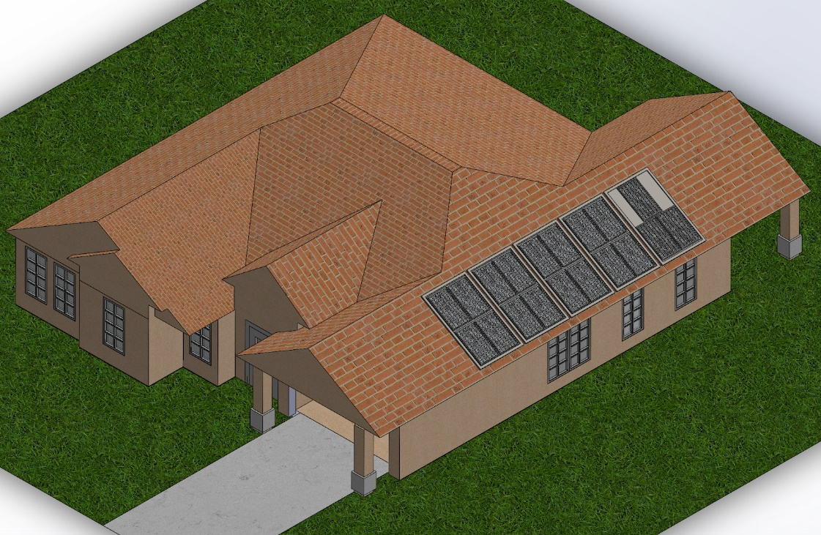

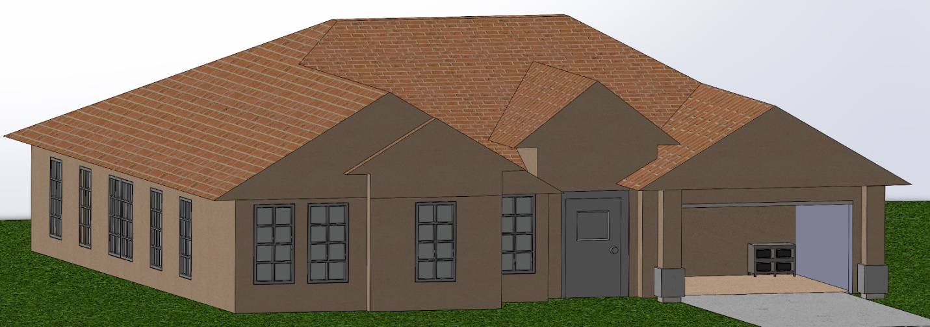

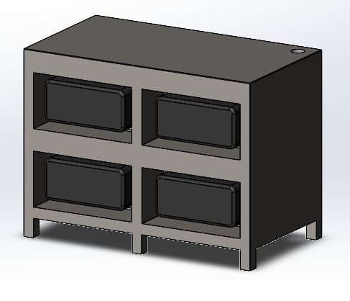

The total cost for our client’s solar home came out to be about $36,352, but they will have an annual saving of $1,606.40. This will take about 22.6 years to pay off just using the money saved. The client’s average annual bill is now only $227.58!

**Schedule Report**

Our project was broken up into four main points. To stay on track with our deadline, certain things had to be done by certain days.

**Milestone 1 – December 2, 2020**

* Decide on:
  + Solar panel
  + Lot #
  + House model
* Calculate Ed and Eo

**Milestone 2 – December 8, 2020**

* Decide on battery
* Design both solar panel and battery
* Recalculate Eo with losses & number of batteries
* House model is 90% complete

**Milestone 3 – December 13, 2020**

* Calculate expenses and NPV
* Complete model is 90% done
* Suggest alternatives

**Milestone 4 – December 17, 2020**

* Present report to client

**MATLAB Model**

Our group had originally begun by calculating all the work based on the data given for the month of September. The team later learned that the “winter season” account began in October rather than September. This caused the group to rework the calculations based on October’s numbers. This was a very easy change and worked out in our favor. Below are all the new calculations for our client’s solar home.

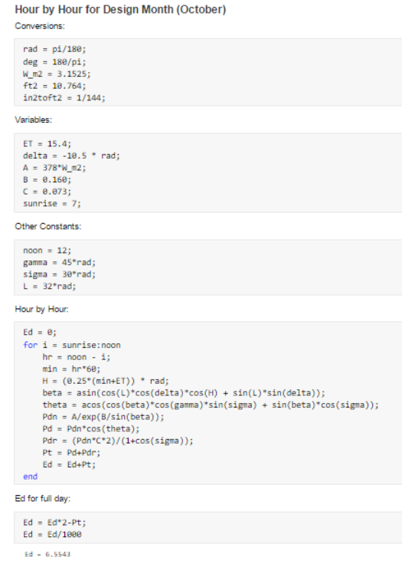

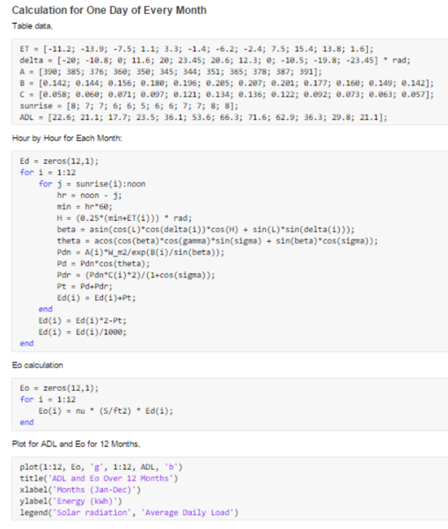

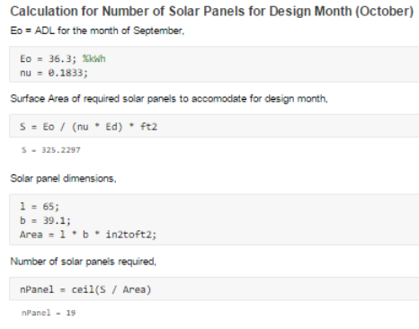

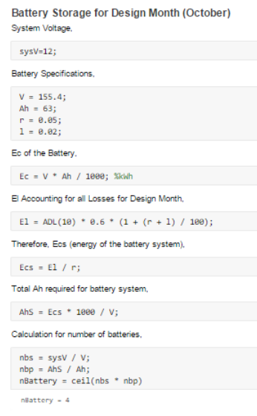October had a drastic drop in energy use. With the change in numbers, our client will only need 19 solar panels now and use saved power rather than 27 solar panels and waste all the extra power.

We also were able to get rid of 2 batteries and now only buy 4. With fewer solar panels, our client will not have as much energy to save.

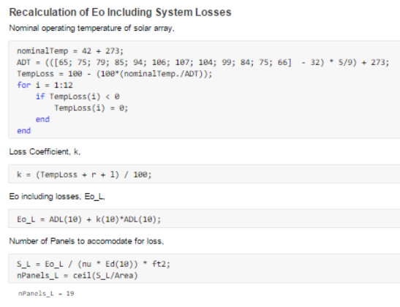

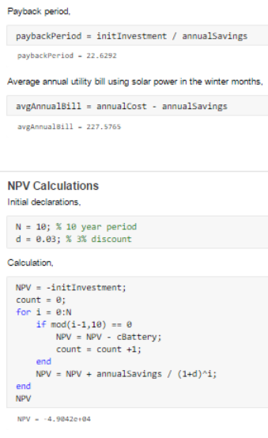

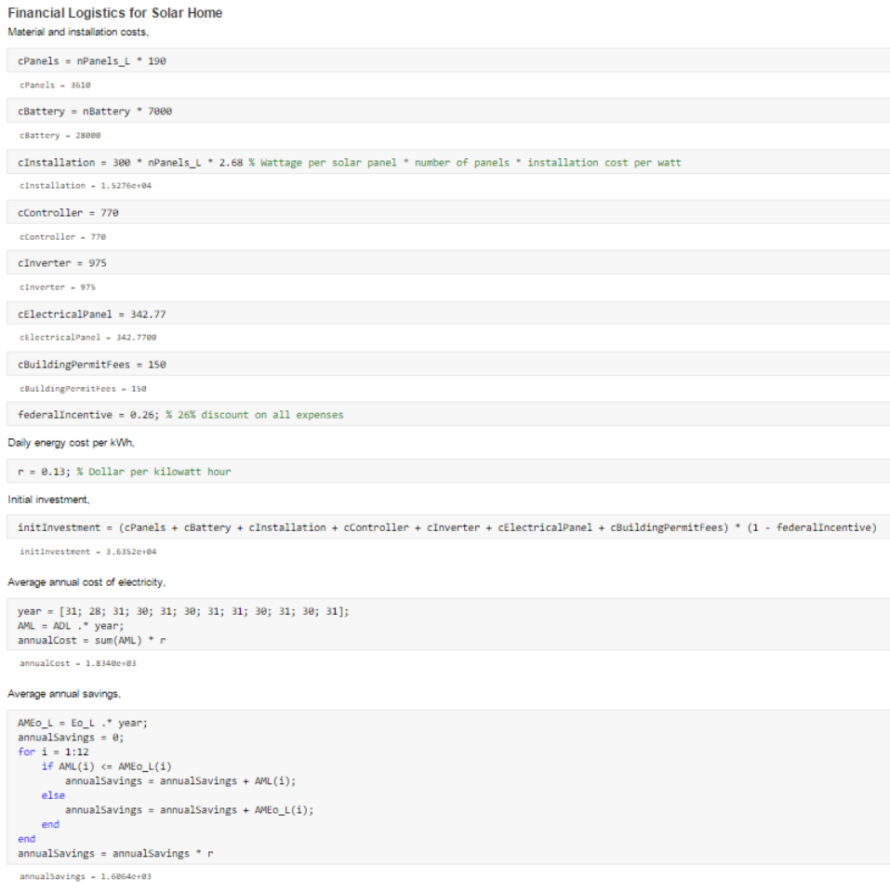

With not as many supplies needed, our group was able to save our client a lot of money and cut the payback period down by a whole lot. Unfortunately, the NPV is negative meaning the client is losing value every 10 years.

**Drawings and Graphs**

After all the parts needed for this house to go green were found, our group was able to create a final 3D model of our client’s home that will best represent what their house will look like. Below shows an isometric, front, and back view of the client’s solar home.

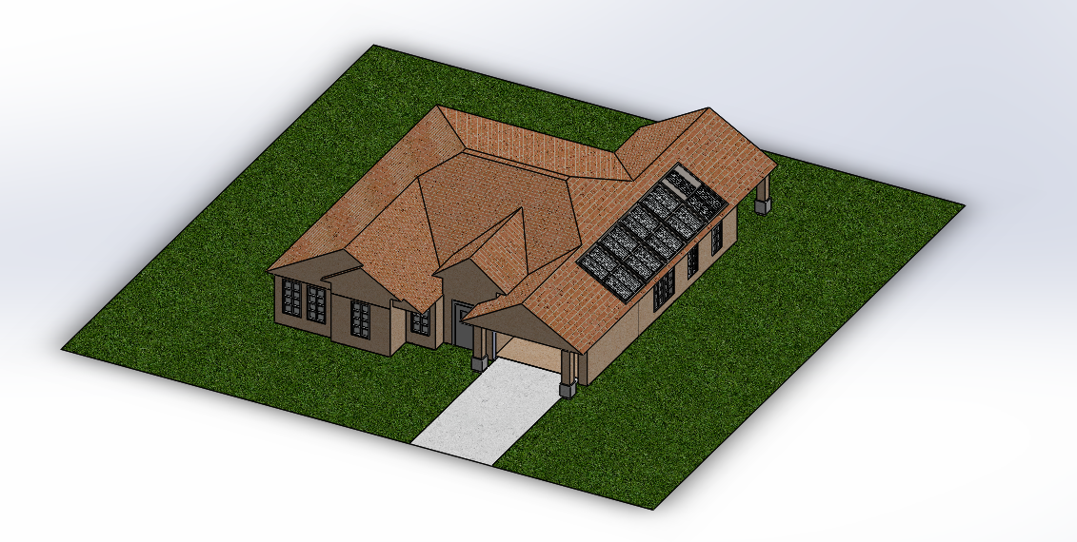

Isometric View



Front View

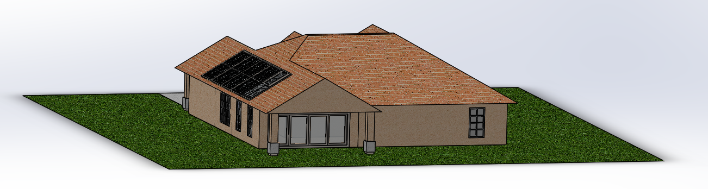

Back View

**Justification of Decisions**

The main economic tradeoff that our client’s solar system is going through is a negative NPV. Our team wanted to use the best products we could get our hands on with no budget in mind. We figured that if our client does not have a budget and is well off for the rest of their time, assuming so, we would rather create the best system we possibly could and not worry about cost.